|  |
| --- |
| Gurkaran Padda |

Humber College Institute of Technology & Advanced Learning Parts Crib Management System CENG35-0NB

# Declaration of Joint Authorship

We, Gurkaran Padda, Ricky Ramnath, and Mohamed Kore, confirm that this work submitted is the joint work of our group and is expressed our own words. Any uses made within it of the works of any other author, in any form (ideas, equations, figures, texts, tables, programs), are properly acknowledged at the point of use. A list of the references used is included. The work breakdown is as follows: Each of us provided functioning, documented hardware for a sensor or effector. Student A provided the RC522 RFID sensor. Student B provided Adafruit Ultimate GPS Breakout. Student C provided COM-14662 12-Button Keypad. In the integration effort Student A is the lead for further development of our mobile application, Student B is the lead for the Hardware, and Student C is the lead for connecting the two via the Database.

# Proposal

We have created a mobile application, worked with databases, completed a software engineering course, and prototyped a small embedded system with a custom PCB as well as an enclosure (3D printed/laser cut). Our Internet of Things (IoT) capstone project uses a distributed computing model of a smart phone application, a database accessible via the internet, an enterprise wireless (capable of storing certificates) connected embedded system prototype with a custom PCB as well as an enclosure (3D printed/laser cut), and are documented via this technical report targeting OACETT certification guidelines.

Intended project key component descriptions and part numbers  
Development platform:   
Sensor/Effector 1: RC522 RFID sensor  
Sensor/Effector 2: Adafruit Ultimate GPS Breakout  
Sensor/Effector 3: COM-14662 12-Button Keypad

We will continue to develop skills to configure operating systems, networks, and embedded systems using these key components to allow the parts crib to keep an electronic catalogue of items loaned out to students. Students will be able to use a mobile android-based application to see what items are available and to request them using their student credentials. The Parts Crib staff will be able to use the admin page through a website to manage inventory and track outstanding items. There will be a common datastore (using Google Firebase) for both the android app and the admin panel to ensure that both students and staff are getting the most current information on the state of the inventory. Sensors will enhance the overall process of borrowing items from the parts crib, the RFID will keep track of data such as student number, name, email addresses and a randomly generated pin, which will allow us to keep track of who takes what from the crib and for easy identification. The RFID will be a much faster and more waste proficient than the traditional paper/student id method that we are currently accustomed to. The Adafruit Ultimate GPS Breakout will allow us to bring students to the location of the Parts Crib. And finally, the COM-14662 12-Button Keypad will server as a multi factor authentication.

Our project description/specifications will be reviewed by, Vlad Porcila, ideally an employer in a position to potentially hire once we graduate. They will also ideally attend the ICT Capstone Expo to see the outcome and be eligible to apply for NSERC funded extension projects. This typically means that they are from a Canadian company that has been revenue generating for a minimum of two years and have a minimum of two full time employees.

The small physical prototypes that we build are to be small and safe enough to be brought to class every week as well as be worked on at home. In alignment with the space below the tray in the Humber North Campus Electronics Parts kit the overall project maximum dimensions are 12 13/16" x 6" x 2 7/8" = 32.5cm x 15.25cm x 7.25cm.

Keeping safety and Z462 in mind, the highest AC voltage that will be used is 16Vrms from a wall adapter from which +/- 15V or as high as 45 VDC can be obtained. Maximum power consumption will not exceed 20 Watts. We are working with prototypes and that prototypes are not to be left powered unattended despite the connectivity that we develop.

# Executive Summary

Explain what accomplishments are described by this document and why your product should be purchased and you should be hired by an investor.

This document aims to describe a breakdown of the implementation plan of the Parts Crib Management System, which is designed to simply allow students to easily borrow parts from the campus parts crib, at a faster and efficient rate compared to the current implemented system. Our implementation plan is as follows: Students will be required to come to the Parts Crib to have a RFID sticker placed on. This sticker will be uniquely tied to their student number as part of the onboarding process. The student will install the application using the Google Play Store, and must be logged on the Humber network to register their student number on to the service. The first loan by the student will require physical verification of the student ID. Our product should be purchased because it aims to nullify any of the current system problems, all while being cost efficient. Since we are also students at Humber College, aiming to create a better Parts Crib Management System will also benefit us and future students, and the employer can use it as an example to demonstrate what future students from this institution are capable of.

Contents

Declaration of Joint Authorship 2

Proposal 3

Executive Summary 5

List of Figures 9

1.0 Introduction 11

1.1 Scope and Requirements 11

2.0 Background 13

3.0 Methodology 15

3.1 Required Resources 15

3.1.1 Parts, Components, Materials 15

3.1.2 Manufacturing 15

3.1.3 Tools and Facilities 15

3.1.4 Shipping, duty, taxes 15

3.1.5 Time expenditure 15

3.2 Development Platform 15

3.2.1 Mobile Application 15

3.2.2 Image/firmware 17

3.2.3 Breadboard/Independent PCBs 17

3.2.4 Printed Circuit Board 19

3.2.5 Enclosure 20

3.3 Integration 21

3.3.1 Wireless Connectivity 22

3.3.2 Database Configuration 22

3.3.3 Security and Testing 22

4.0 Results and Discussions 23

5.0 Conclusions 25

6.0 References 27

7.0 Appendix 29

7.1 Firmware code 29

7.2 Application code 29

# List of Figures

Figure 7. By Android Studio - https://developer.android.com/studio/, CC BY-SA 4.0, https://commons.wikimedia.org/w/index.php?curid=74094999 17

Figure 1. Initial schematic. This work is a derivative of "http://fritzing.org/parts/" by Fritzing, used under CC:BY-SA 3.0. 18

Figure 2. This work is a derivative of "http://fritzing.org/parts/" by Fritzing, used under CC:BY-SA 3.0. 18

Figure 3. Breadboard prototype. 19

Figure 4. PCB design This work is a derivative of "http://fritzing.org/parts/" by Fritzing, used under CC:BY-SA 3.0. 20

Figure 5. Humber Sense Hat Prototype PCB. 20

Figure 6. Example enclosure. 21

# 1.0 Introduction

Idea. Self-driving cars using Machine Learning. Scope and Requirements specification. Project Schedule.

## 1.1 Scope and Requirements

The parts crib management system will implement a system that will allow the parts crib to keep an electronic catalogue of items loaned out to students. Students will be able to use a mobile android-based application to see what items are available and to request them using their student credentials. An RFID Scanner, GPS Sensor, and a Keypad System will allow us to achieve this. Our goal is to make this a more efficient and easier way of borrowing parts from the parts crib. It is a goal of our group to make this project industry worthy for any application. We are assuming we’re capable of putting RFID tags on everyone’s student ID in the parts management system. We can also assume that the inventory of the parts crib is given to us so we’re able to put it into our database for when it comes to distribution of parts. We’re dependent on the Admins at the parts crib to be able to read the system and be able to handle the intake of item requests given to them by the users.

Report

/1 Hardware present?

/1 Introduction (500 words)

/1 Scope and Requirements

/1 Background (500 words)

/1 References

# 2.0 Background

We would like to thank mentor Diego Magalhães from AWS for supporting this project. This section is to include at least three references, here is an example of an APA citation of a website (OACETT, 2017) followed by a sentence citing an Article in a Periodical, a Book, and a Journal Article. Humber is planning to host an internal DeepRacer event using an existing example of machine learning (Robuck, 2018), artificial intelligence (Media, O., 2019), and internet connected servers (Kinsella, 2019).

# 3.0 Methodology

## 3.1 Required Resources

Report

/1 Parts/components/materials (500 words)

/1 PCB, case (500 words)

/1 Tools, facilities (500 words)

/1 Shipping, duty, taxes (250 words)

/1 Working time versus lead time (250 words)

### 3.1.1 Parts, Components, Materials

### 3.1.2 Manufacturing

### 3.1.3 Tools and Facilities

For our parts crib management system, most of the tools required for testing the hardware, are either already given to us in our classroom or we already have it with us at all times in our toolboxes. For testing on our hardware’s PCB Board, we will be using multimeters in order to find any connection continuity errors. Some other components that we may need to borrow for our hardware design, such as the helping hand for holding the PCB board, will be acquired from the parts crib. For the mobile application component of the capstone project, our lab computers already come with the software tools that we need in order to finish and fine tune building our app, such as Android studio and SDK tools which can be used to program and emulate our mobile app and troubleshoot any problems that may occur, also, test how it would feel for a user using our app. The software tool for the hardware enclosure design such as CorelDraw will be used in order to achieve precise measurements that will hold all our hardware components. Also, for the PCB board testing, the software tool we will be using is Fritzing which allows us to create PCB boards and test our connections and export them as pdf files which will be sent to the Prototype Lab facility for cutting. In terms of facilities we will be using, most of our time spent will be in the labs, where we will continue to build upon our project. Other facilities we are considering incorporating into our project will be the Idea lab. The Idea lab at Humber College offers a 3D printing workshop session which we have/will attend in order to understand how to use the 3D printers so we can begin using the lab for 3D prints and testing designs to find out what works/fits well and for other minor improvements we could make to the enclosure. We will be using the 3D for creating the enclosure for our hardware components. Another facility that we will be using is the Prototype Lab frequently in order to create our PCB boards which will adhere to the requires of the lab, being made from copper and having vias the size of 3-5mm. It is likely that problems/errors will occur in the creation of our PCB boards, so visiting the Prototype Lab will be needed in order to make those. The Prototype Lab also offers a laser cutter which uses a multiple of materials such as acrylic, wood, etc. Prototype Lab is also where our collaborator Vlad is stationed, so it gives us the perk of being able to directly show off our progress and gives us the chance to add features/make chances to either the mobile application or the hardware design. A finish product of our project will consider using the laser cutter and all the other tools available in these facilities in order to achieve standards that will please our collaborator’s requests and create a product that can be used for demonstrating our abilities.

### 3.1.4 Shipping, duty, taxes

### 3.1.5 Time expenditure

Working time versus lead time.

## 3.2 Development Platform

### 3.2.1 Mobile Application

Status

/1 Hardware present?

/1 Memo by student A + How did you make your Mobile Application? (500 words)

/1 Login activity

/1 Data visualization activity

/1 Action control activity

Include screenshots such as Figure 1. Testing. Progress.

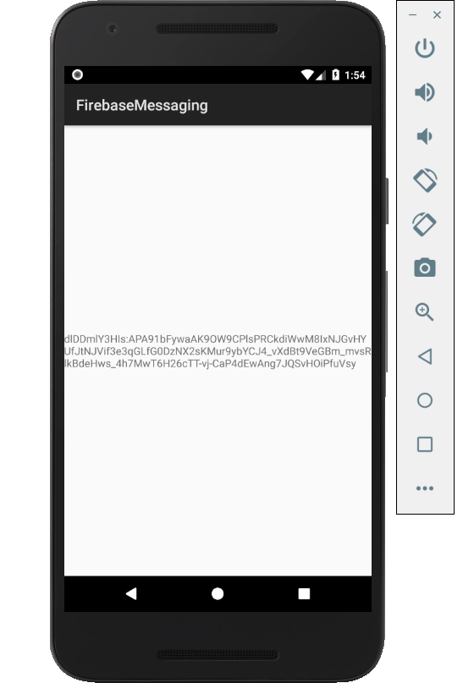

Figure 1. By Android Studio - https://developer.android.com/studio/, CC BY-SA 4.0, https://commons.wikimedia.org/w/index.php?curid=74094999

### 3.2.2 Image/firmware

Status

/1 Hardware present?

/1 Memo by student B + How did you make your Image/firmware? (500 words)

/1 Code can be run via serial or remote desktop

/1 Wireless connectivity

/1 Sensor/effector code on repository

### 3.2.3 Breadboard/Independent PCBs

Status

/1 Hardware present?

/1 Memo by student C + How did you make your hardware? (500 words)

/1 Sensor/effector 1 functional

/1 Sensor/effector 2 functional

/1 Sensor/effector 3 functional

The initial schematic design, Figure 2, based on datasheets (Bosch Sensortec, 2019) led to a breadboard layout Figure 3 that was realized Figure 4.

How did you build your Prototype: Breadboard?

Then a PCB was designed, Figure 5, and populated (Figure 6). Bill of Materials, Case, Time commitment. Testing. Progress.

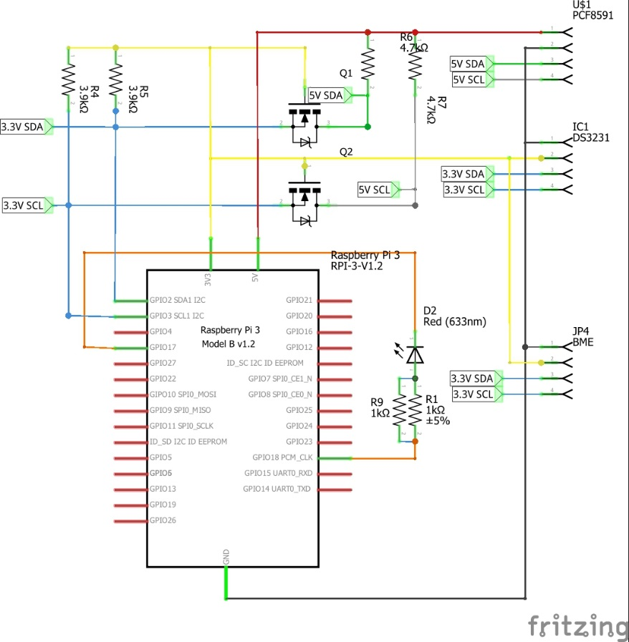

Figure 2. Initial schematic. This work is a derivative of "http://fritzing.org/parts/" by Fritzing, used under CC:BY-SA 3.0.

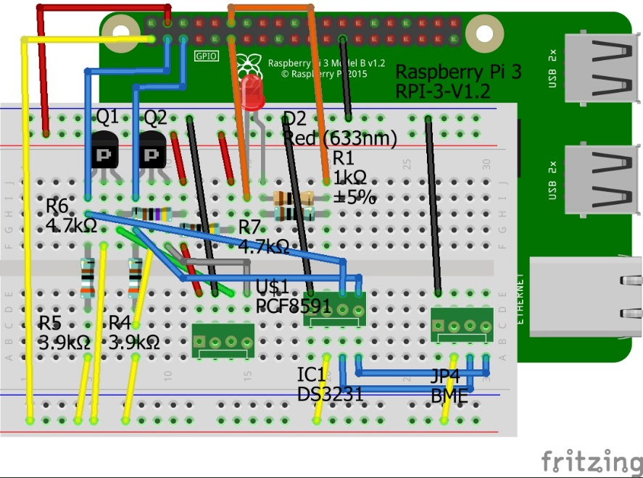

Figure 3. This work is a derivative of "http://fritzing.org/parts/" by Fritzing, used under CC:BY-SA 3.0.

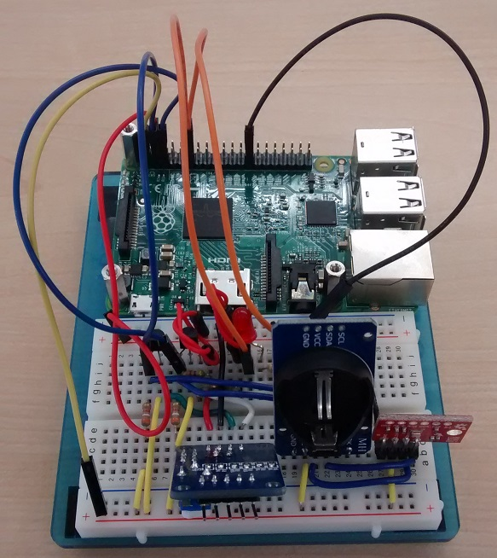

Figure 4. Breadboard prototype.

### 3.2.4 Printed Circuit Board

Demo

/1 Hardware present?

/1 PCB Complete and correct

/1 PCB Soldered wire visible but trim, no holes or vacancies

/1 PCB Tested with multimeter

/1 PCB Powered up

How did you build your Prototype: PCB?

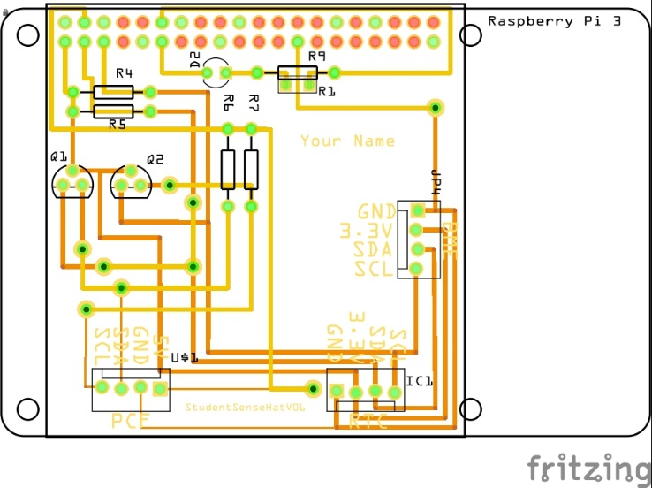

Figure 5. PCB design This work is a derivative of "http://fritzing.org/parts/" by Fritzing, used under CC:BY-SA 3.0.

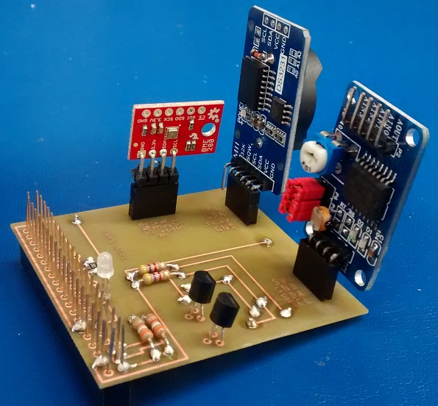

Figure 6. Humber Sense Hat Prototype PCB.

### 3.2.5 Enclosure

Demo

/1 Hardware present?

/1 Case encloses development platform and custom PCB.

/1 Appropriate parts securely attached.

/1 Appropriate parts accessible.

/1 Design file in repository, photo in report.

How did you build your Prototype: Case?

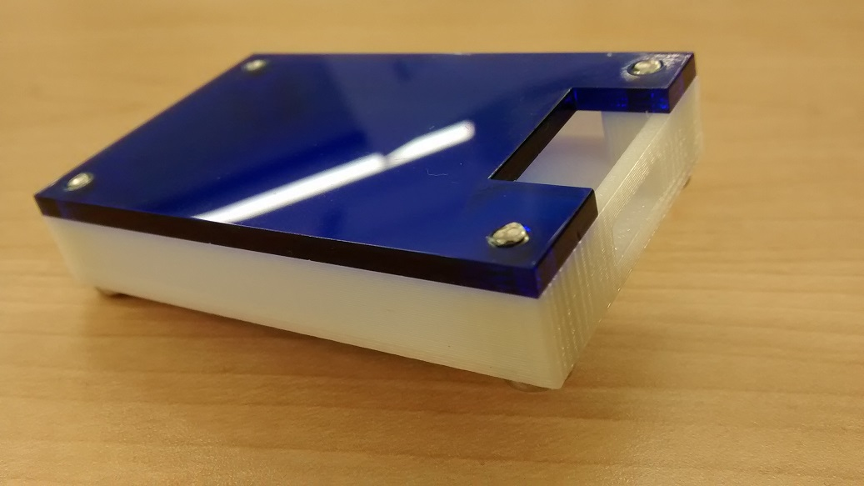

Figure . Example enclosure.

## 3.3 Integration

Demo

/1 Hardware present?

/1 Data sent by hardware

/1 Data retrieved by mobile application

/1 Action initiated by mobile application

/1 Action recieved by hardware

Report

/1 Enterprise wireless connectivity (250)

/1 Database configuration (250 words)

/1 Security considerations (500 words)

/1 Unit testing (900 words)

/1 Production testing (100 words)

### 3.3.1 Enterprise Wireless Connectivity

How did you make a Database accessible by both your Prototype and Mobile Application?

### 3.3.2 Database Configuration

### 3.3.3 Security

### 3.3.4 Testing

Unit testing and Production testing.

# 4.0 Results and Discussions

Is your prototype perfect? What did you learn?

# 5.0 Conclusions

If you were making 1000 of these.

Report

/1 Hardware present?

/1 Checklist truthful

/1 Valid Comments

/1 Results and Discussion (500 words)

/1 Conclusion

# 6.0 References

Bosch Sensortec. (2019, July). *BME680 - Datasheet.* Retrieved from Robert Bosch GmbH: https://ae-bst.resource.bosch.com/media/_tech/media/datasheets/BST-BME680-DS001.pdf

Kinsella, J. (2019). Five trends predicted for the cloud industry in 2019. *Software World*, 50(1), 11.

Media, O. (2019). *O'Reilly artificial intelligence conference 2019 - San Jose, California.* California: O'Reilly Media, Inc.

OACETT. (2017, March). *I need to Complete a Technology Report*. Retrieved from The Ontario Association of Certified Engineering Technicians and Technologists: https://www.oacett.org/Membership/Technology-Report-and-Seminar

Robuck, M. (2018, 11). AWS goes deep and wide with machine learning services and capabilities. *Fierceinstaller*.

# 7.0 Appendix

## 7.1 Firmware code

Demo

/1 Hardware present?

/3 Code runs concurrently for all sensors/effectors

/1 Project repository contains integrated code

Status

/1 Memo including updates

/1 Financial update

/1 Progress update

/1 Modified Code Files in Appendix

/1 Link to Complete Code in Repository

## 7.2 Application code

Demo

/1 Hardware present?

/1 Memo by student A

/1 Login activity

/1 Data visualization activity

/1 Action control activity

Report

/1 Login activity

/1 Data visualization activity

/1 Action control activity

/1 Modified Code Files in Appendix

/1 Link to Complete Code in Repository